Epsom & Ewell F.C.
17
v
Bedfont Sports
Saturday, 24th March 2018 – 3.00 p.m.
Good afternoon and welcome to High Road for our League match against Bedfont Sports. We welcome their players, supporters and officials and wish them a safe journey home, as of course we do for our own regular supporters.

Bedfont Sports have grown from humble beginnings and are now looking to progress higher up the pyramid in a relatively short space of time. Their ground is now one of the best appointed at Step Five and would not look out of place at Step Three! Behind Westfield, it appears that both they and Sutton Common Rovers are the two teams battling it out for the runners-up spot and the now confirmed automatic promotion place that goes with it. Their important meeting takes place at Sutton on 7th April. I’m sure I speak for most Epsom supporters when I say that we’d rather it were Bedfont Sports who gained that spot!

We were last here on Tuesday 13th March when we were narrowly defeated by Balham who scored twice in the second half to defeat us 2-0. I thought we were well worth a point from this match and were unfortunate to lose it, but teams higher up the table find a way of pinching the result more often than not.

Then we were due to travel to North Greenford United on Saturday but the pitch was waterlogged long before the snow arrived there! We now go there on Thursday 19th April.

Following today’s encounter we have two further home matches in quick succession as we host Colliers Wood on Good Friday and Banstead Athletic on Easter Monday with both kicking off at 11.30 a.m. These are massive matches for our club, so please bring your friends.

I also apologise for the shortened programme this afternoon. Our regular day in history and A-Z sections will return for the Easter programme which will, due to printing deadlines, be a double issue. People have asked me what will I do once the A-Z has been completed, which it will be in the final programme of the year. I shall just start it all again though, seeing as it has taken seven years to produce, and obviously will have updated much since its first release!

Our anniversary month is almost complete but we are still marking our Centenary all year. We will shortly be announcing our Centenary Dinner and releasing details and should have our Centenary kit on show shortly too.

Enjoy the game!

Rich

Don’t forget, you can now follow us on Social Media. Please see the inside cover for addresses.

Cover photos by Gemma Jarman – previous wins against Bedfont Sports

- Daryl Cooper-Smith scores our equaliser in our 5-1 win over Bedfont Sports in Nov 2016
- Our Captain Alex McKay heads a late winner to beat Bedfont Sports 1-0 in September 2013
1
Cherry Red Records Combined Counties League
Premier Division Table 2017/18
inc Wednesday 21st March | P | W | D | L | F | A | Pts | GD | H | A
Westfield | 31 | 28 | 1 | 2 | 115 | 30 | 85 | +85 | 14/4 | 0-5
Bedfont Sports | 35 | 24 | 5 | 6 | 88 | 51 | 77 | +37 | 24/3 | 0-7
Sutton Common Rovers | 34 | 24 | 3 | 7 | 81 | 39 | 75 | +42 | 0-2 | 0-5
Walton & Hersham | 34 | 20 | 6 | 8 | 70 | 43 | 66 | +27 | 0-2 | 24/4
Camberley Town | 34 | 11 | 19 | 4 | 44 | 34 | 52 | +10 | 0-0 | 1-1
Horley Town | 33 | 14 | 7 | 12 | 52 | 64 | 49 | -12 | 2-3 | 2-3
Knaphill | 32 | 13 | 9 | 10 | 60 | 52 | 48 | +8 | 0-0 | 2-6
Balham | 29 | 14 | 5 | 10 | 59 | 48 | 47 | +11 | 0-2 | 0-4
CB Hounslow United | 31 | 14 | 4 | 13 | 55 | 45 | 46 | +10 | 17/4 | 2-4
Spelthorne Sports | 35 | 13 | 7 | 15 | 55 | 53 | 46 | +2 | 1-5 | 0-0
Redhill | 32 | 13 | 4 | 15 | 55 | 56 | 43 | -1 | 0-5 | 0-3
Hanworth Villa | 32 | 11 | 9 | 12 | 55 | 66 | 42 | -11 | 1-1 | 3-2
Guildford City | 34 | 11 | 7 | 16 | 56 | 73 | 40 | -17 | 1-3 | 7/4
Abbey Rangers | 32 | 10 | 9 | 13 | 48 | 49 | 39 | -1 | 1-1 | 0-0
North Greenford United | 26 | 10 | 7 | 9 | 47 | 42 | 37 | +5 | 1-2 | 19/4
Colliers Wood United | 31 | 10 | 4 | 17 | 54 | 58 | 34 | -4 | 30/3 | 2-5
Chertsey Town | 33 | 9 | 5 | 19 | 53 | 72 | 32 | -19 | 2-7 | 0-1
AFC Hayes | 30 | 8 | 6 | 16 | 41 | 61 | 30 | -20 | 28/4 | 0-2
Godalming Town | 33 | 8 | 6 | 19 | 41 | 70 | 30 | -29 | 0-3 | 2-1
Banstead Athletic | 32 | 8 | 6 | 18 | 40 | 72 | 30 | -32 | 2/4 | 1-1
Farnham Town | 32 | 5 | 8 | 19 | 41 | 73 | 23 | -32 | 3-0 | 0-0
Epsom and Ewell | 33 | 3 | 9 | 21 | 27 | 86 | 18 | -59 | X | X

Lucky Day? – 24th March
Played 13 - Won 8 Drawn 2 Lost 3 - For 33 Against 24 - PPG 2.00 - Very Good
Our Club record against Bedfont Sports
Played 12 - Won 7 Drawn 2 Lost 3 - For 21 Against 19 - PPG 1.92 - Very Good
Largest wins and losses against Bedfont Sports
19th November 2016 - Won 5-1 - Combined Counties League Cup (A)
4th November 2017 - Lost 0-7 - Combined Counties League (A)
Bedfont Sports’ Last Visit
Saturday 19th November 2016 - Won 5-1 - Combined Counties League

Recent Results and Fixtures
Combined Counties League – Tuesday 13th March 2018
Banstead Athletic | 1-2 | Bedfont Sports
Epsom & Ewell | 0-2 | Balham
Hanworth Villa | 2-2 | Horley Town
Redhill | 4-3 | CB Hounslow United
Combined Counties League – Wednesday 14th March 2018
Colliers Wood United | 1-0 | Chertsey Town
Combined Counties League – Saturday 17th March 2018
Bedfont Sports | 0-0 | Camberley Town
Chertsey Town | 1-1 | AFC Hayes
Guildford City | 2-4 | Westfield
Horley Town | 2-1 | Banstead Athletic
North Greenford United | p-p | Epsom & Ewell
Redhill | 3-1 | Balham
Spelthorne Sports | 1-0 | Abbey Rangers
Sutton Common Rovers | 11-1 | Farnham Town
Walton & Hersham | 2-4 | CB Hounslow United
Combined Counties League Cup SF – Tuesday 20th March 2018
Walton & Hersham | 1-2 | Knaphill
Combined Counties League – Tuesday 20th March 2018
Abbey Rangers | 5-0 | Guildford City
Bedfont Sports | 3-2 | Godalming Town
Camberley Town | 0-1 | Banstead Athletic
Farnham Town | 2-3 | Colliers Wood United
North Greenford United | p-p | Westfield
Combined Counties League – Wednesday 21st March 2018
Balham | 3-0 | AFC Hayes
Combined Counties League – Thursday 22nd March 2018
North Greenford United | V | Camberley Town
Combined Counties League Cup SF – Saturday 24th March 2018
Worcester Park | V | Sutton Common Rovers
Combined Counties League – Saturday 24th March 2018
Abbey Rangers | V | Horley Town
AFC Hayes | V | Guildford City
CB Hounslow United | V | Chertsey Town
Colliers Wood United | V | North Greenford United
Epsom & Ewell | V | Bedfont Sports
Farnham Town | V | Knaphill
Godalming Town | V | Spelthorne Sports
Hanworth Villa | V | Redhill
Westfield | V | Banstead Athletic
Combined Counties League – Tuesday 27th March 2018
AFC Hayes | V | Abbey Rangers
Banstead Athletic | V | North Greenford United
Camberley Town | V | Sutton Common Rovers
Farnham Town | V | Redhill
Knaphill | V | CB Hounslow United
Westfield | V | Walton & Hersham

From behind the goal
Epsom & Ewell 0-0 Camberley Town
Combined Counties League - Premier Division - Saturday 10th March 2018

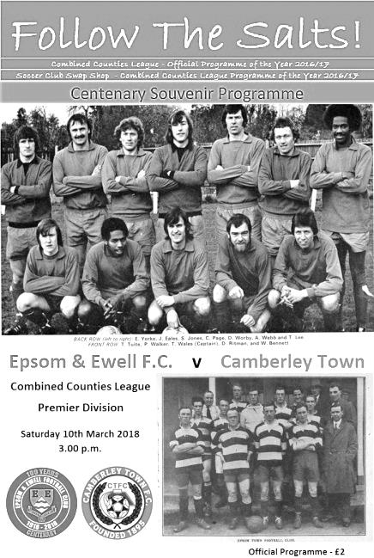
Salts unable to break the Camberley resistance

After a fortnight's enforced break due to wintry conditions it was "as you were" at High Road as we repeated the 0-0 scoreline from our two previous matches to set a goalless sequence that is the second longest in our history. However, unlike the two previous matches where we were pushed back towards the end, it was our boys who were holding the majority of the possession, but were unable to break through despite playing against ten men for whole of the second half.

We only made two changes from our draw with Knaphill as Marlon Pinder and Alex McKay returned to the starting eleven for Rory Sellick who was on the bench and the absent Reisse Griffin. This meant that Sean Masterson continued at left back. The line-up is certainly looking more stable these days and we went into the encounter on a run of just one defeat in seven matches, which would be extended with this result.

However, our visitors were on an unbeaten run of 14 matches and sat in the top five. They would present a difficult challenge and they fired an early shot high and wide from about twenty yards. They fashioned another opportunity on the 15 minute mark when a low ball in from the right was met by a low shot which Conor Young kept out at his near post.

We started to create some chances of our own after this. In the 22nd minute a great crossfield ball from Lloyd Connelly found Pinder at the far post and he cut inside his man before firing a curling effort just beyond the far post of the Camberley goal from about 15 yards. Two minutes later it was Liam Roberts who switched play from one flank to the other with a deep ball which Scott Murphy did really well to head back across goal where Kyen Nicholas was waiting to put a solid header goalwards from six yards. Unfortunately for us, it was straight at Adam Desbois in the Camberley goal and to his credit he was able to hold on to the ball as well.

Connelly then saw his shot blocked behind and Desbois was alert to punch away the subsequent Masterson corner but in all honesty this was a half of few good chances and apart from a free kick that Young gathered easily and another scary moment where our keeper dwelt on the ball and almost paid the ultimate price for it, the half began to fizzle out.

What no one expected was for the half to explode into life right at the end of the 45! For me the trouble started when Masterson was late with a challenge on his opponent and in my opinion it looked like a very clear yellow card. Luckily he got away with just a warning but I wondered whether such a relaxed attitude by the referee would prove an issue later on. We found out the answer to that before play had even restarted when there was an incident between the two

Captains with McKay ending up on the floor, which led to the obligatory scuffle between the players. The referee clearly didn't see what had happened in amongst the group of players that had retreated for the free kick. He spoke to both Captains and issued an instruction to calm down, but within a few seconds of the free kick being cleared Stuart Derry scythed through Roberts, leaving our man on the turf.

Now, some say that the incident only warranted a yellow card and certainly we have seen many instances of a player remaining on the field after such a challenge, but bearing in mind that this challenge came immediately after the instruction for calm, would indicate a degree of pre-meditation and this is probably why Derry received a straight red card.

This of course raised the stakes for our boys too. Knowing that we needed some wins urgently, we weren't going to get many better chances than playing against ten men and needed to turn this into a win. Camberley responded by putting on two substitutes at half time with Youth team star Dean Rule coming on up front and adding the experienced head of Dale Webb, who had played for the Krooners when they reached the F.A.Vase Quarter-Final a couple of years back. Both had an effect as Webb shut down our main striking threat of Nicholas while Rule showed huge potential and plenty of threat.

Most would have expected Camberley to hit us on the break as we pushed for the win in the second half. It didn't quite turn out like that to begin with as Camberley had more of the possession in the opening stages and we weren't helping our own cause. Roberts lost the ball twice in quick succession right in front of the bench and was replaced almost immediately by Miguel Anderson with Pinder switched to Roberts vacated position on the right.

As Camberley attacked, Rule reached the touchline and sent a ball straight across the face of our goal but by the hour mark we were doing most of the threatening. We almost received a helping hand (or foot) as Desbois sent a poor goal kick straight to Nicholas whose touch let him down. The loose ball was fed back to the keeper who then sliced the back pass up in the air, but our centre-forward tried to control it when maybe a first time effort at an open goal might have been a better option and the chance was gone.

Pinder was at the far post to meet a deep Connelly cross but his contact just looped the ball into the air, but then we had another worry at our end when Endrit Dobraj was in the right place to clear a shot off our goal line. We introduced Alvin MacAuley for Connelly and he nearly marked his debut with a goal when an Adam Heagney free kick into the box wasn't dealt with, but his shot lacked a bit of power and Desbois was down smartly to make the save from 12 yards.

As the game meandered into injury time the visitors nearly pinched the points. Firstly after a good run from Fred Kelsey was ended unfairly on the edge of our box, although fortunately the free kick was well covered by Young. Then seconds later Rule cut in from the left and hit a shot that came back off the base of our far post and fortunately away to safety. A defeat would have been really harsh on our boys as we were definitely well worth at least a point in this match but with just ten contests remaining our pre-Christmas form is really proving to be a mountain to climb, and even a draw, good result though it was against a team sitting in fifth place, still leaves us in the foothills.

Epsom and Ewell: Conor Young, Endrit Dobraj, Sean Masterson, Adam Heagney, Alex McKay (c), Ashley Thompson, Marlon Pinder, Scott Murphy, Kyen Nicholas, Lloyd Connelly, Liam Roberts

Subs: Miguel Anderson for Roberts (55), Alvin MacAuley for Connelly (70), Ben Dyson for Masterson (85)

Sponsor's Player of the Match: Alex McKay

From behind the goal
Epsom & Ewell 0-2 Balham
Combined Counties League - Premier Division - Tuesday 13th March 2018

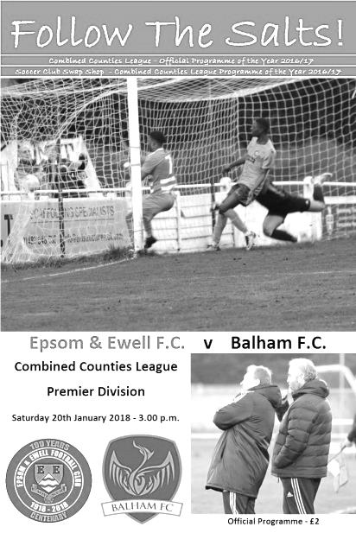
Balham complete League double with a second half brace

The Salts were unfortunate to be defeated by Balham on Tuesday evening, having battled our opponents all the way only to be undone by a good set piece delivery and a freak goal.

In terms of personnel, Reisse Griffin returned at left back in place of Shaun Masterson and Rory Sellick and Miguel Anderson also rejoined the starting eleven after starting Saturday's match on the bench. Kyen Nicholas and the absent Liam Roberts were the ones to make way.

The first half contained little to get the crowd of 29 excited from either side. The visitors sent a shot across our bar while Anderson made a good run on the right but the ball in was behind Lloyd Connelly, playing in the centre, although he did well to direct a shot that was just wide of the post.

In response Balham had a decent opportunity when a near post corner was fired over Conor Young's goal from about ten yards out after 15 minutes, but apart from a header just over our bar and a couple of long range attempts from either team that failed to trouble either keeper, we went in at the half goalless.

This was our seventh consecutive opening half without scoring, which we hadn't managed for nine years, but we weren't looking in any particular trouble either and a fourth straight goalless draw would have been the expectation for most of those present. Unfortunately that thought was removed in the 49th minute as a well-placed corner was headed in by Ibs Olutade from close range. Young's run of 319 minutes without conceding was still a great achievement though and worth noting here.

In response Marlon Pinder cut in from the left and his cross/shot caught Mike Neish in the Balham goal out slightly, requiring him to get the faintest of touches on the ball which then hit the bar and went out for a corner. From that delivery the visitors didn't clear the danger and Scott Murphy found Sellick with a clever ball to

the far post, but our man screwed his shot across goal from just eight yards out and the danger was finally cleared.

Balham could and probably should have scored a second goal when a low delivery from the left wing was struck wide of our post from just ten yards out while Anderson and Sellick both put shots over the bar; the latter after being set up nicely by Pinder.

Young produced a great save to turn a low shot from Arsen Ojraj around the post, only to see the goal kick awarded and the decision not questioned by the Balham player! I had to check with those around me that my eyes hadn't deceived me, but they also saw our man getting a touch to the ball which was definitely going to creep inside the post otherwise.

Connelly got through on goal but was denied by a good challenge and this also happened a few minutes later to substitute Nicholas with the ball rebounding off him and falling kindly for Neish.

By this time we had changed formation and introduced a more attacking option with the returning Louis O'Brien and Joe Loftus-Cheek entering the fray, and it must be said that we did provide more of a threat as a result. Unfortunately and somewhat harshly on Young, his clearance rebounded off the incoming James Adebayo and fell straight into the striker's path, enabling him to roll the ball into the empty net for their second goal in the 90th minute.

It was a cruel ending to the game but sometimes these things happen and we were already a goal down by then, so it's not as if it cost us a point in the end. We battled throughout but were unable to unlock a well marshalled defensive unit that Balham don't get the credit for in my opinion. People see them as a high scoring unit, particularly after their 8-4 win at promotion chasing Bedfont Sports last month, but I can report that they are a fine all round side who will probably finish fifth if they can avoid injuries during the heavy workload of matches that remain on their schedule.

For our boys, we can look back at another decent performance against a good team, although the problem we face is how to become more of an attacking threat in the limited time that remains.

Epsom and Ewell: Conor Young, Endrit Dobraj, Reisse Griffin, Adam Heagney, Alex McKay (c), Ashley Thompson, Marlon Pinder, Scott Murphy, Lloyd Connelly, Rory Sellick, Miguel Anderson

Subs: Kyen Nicholas for Murphy (63), Louis O'Brien for Connelly (75), Joe Loftus-Cheek for McKay (75)

Bedfont Sports F.C. – History
Bedfont Sports Club was founded in 2002, when with considerable help from the local Council a lease was taken out on the near derelict Hatton Road Recreation Ground.

The only building on the site was refurbished to allow use as a bar and clubhouse on the ground floor and changing rooms on the upper one. Most of this work was carried out or supervised by the Chairman Dave Reader. Much work was also done to the playing area to provide playable pitches for Bedfont Sports on Saturdays and Bedfont Sunday, one of the oldest Sunday teams in Middlesex, on Sundays. To give the Club a junior section Bedfont Eagles, formed in 1978, joined the two adult Clubs a short time later.

Bedfont Sports started in the Hounslow and District League for two seasons and then joined the Middlesex County Football League, this being a feeder League to Step 5. More work was needed to enable the team to play in the Premier Division of the MCFL to which they gained promotion in 2004/05. After many ups and downs promotion was finally achieved to the Combined Counties Reserve Division in season 2008/09.

During this time applications were made to the F A and the Football Foundation for funds to enable Flood Lights and a new Dressing Room block to be built together with a 3G five a side pitch. This finally materialised in 2010/11 to give the state of the art complex now available at Bedfont Sports with 500 seats in four stands on all four sides of the ground, which now provides one of the best facilities not only in Middlesex but in the South of England.

In the Combined Counties League Bedfont gained promotion to the Premier Division in season 2011/12 and have spent the past few seasons consolidating that position.

Permanent fencing now surrounds the ground and a 150 seater stand has been installed with a full 3g Astroturf surface to be installed in the next few weeks.

Bedfont Sports is a true Community Club catering for 23 Junior Teams, a girls section, a youth section and two adult teams on a Saturday and Sunday.

The Youth Section is particularly vibrant sitting at the top of the Western Division of the Ryman Youth League and having won the Combined Counties under 18 Cup twice in the last four seasons.

We are very proud that our Youth teams have been home-grown from Bedfont Eagles and with some real talent coming through this should continue for years to come.

A Club such as Bedfont Sports could not exist without sponsors so a big thank you to them and to the volunteers who give their time on match days and to the marking and upkeep of the ground and facilities.

CCL Premier Division Club Directory
ABBEY RANGERS Telephone: 01932-422962 - Ground: Addlestone Moor, Addlestone, Surrey KT15 2QH - Colours: Black & White Stripes/Black/Black

A.F.C. HAYES Telephone: 0208-845-0110 - Ground: Farm Park, Kingshill Avenue, Hayes, Middx. UB4 8DD - Colours: Blue and White Stripes/Blue/Blue

BADSHOT LEA Telephone: 01252-320385 - Ground: Ash United FC, Shawfield Stadium, Youngs Drive, Shawfields Road, Ash, Hampshire. GU12 6RE - Colours: Claret/White/Claret

BEDFONT & FELTHAM Telephone: 0208 890 7264 - Ground: The Orchard, Hatton Road, Bedfont, Middx TW14 9QT - Colours: Yellow & Blue/Blue/Blue

BEDFONT SPORTS Telephone: 0208-831-9067 - Ground: Bedfont Sports Club, Hatton Road, Bedfont, Middx TW14 8JA - Colours: Red & Black Hoops/Black/Red & Black Hoops

CAMBERLEY TOWN Telephone: 01276-65392 - Ground: Krooner Park, Wilton Road, Camberley, Surrey. GU15 2QW - Colours: Red & White Stripes/Blue/Red

CB HOUNSLOW UNITED Telephone: 0208 890 7264 - Ground: The Orchard, Hatton Road, Bedfont, Middx TW14 9QT - Colours: Green/Black/Green

CHERTSEY TOWN Telephone: 01932-561774 - Ground: Alwyns Lane, Chertsey, Surrey. KT16 9DW - Colours: Royal Blue & White Stripes/Royal Blue/Royal Blue

COLLIERS WOOD UNITED Telephone: 0208-942 8062 - Ground: Wibbandune Sports Ground, Robin Hood Way, Wimbledon. SW20 0AA - Colours: Blue & Black Stripes/Black/Black
EPSOM & EWELL Telephone: 01737-553250 - Ground: Chipstead FC, High Road, Chipstead, Surrey. CR5 3SF - Colours: Royal Blue & White Hoops/Royal Blue/Royal Blue

FARNHAM TOWN Telephone: 01252-715305 Ground: Memorial Ground, Babbs Mead, West Street, Farnham, Surrey. GU9 7DY Colours: - Claret & Sky Blue /White/ Claret & Sky Blue

GUILDFORD CITY Telephone: 01483-443322 - Ground: The Spectrum, Parkway, Guildford, Surrey. GU1 1UP - Colours: Red & White Stripes/Black/Black

HANWORTH VILLA Telephone: 0208-831-9391 - Ground: Rectory Meadows, Park Road, off Hounslow Road, Hanworth, Middlesex. TW13 6PN - Colours: Red & White Stripes/Black/Black

HARTLEY WINTNEY Telephone: 01252-843586 - Ground: Memorial Playing Fields, Green Lane, Hartley Wintney, Hants RG27 8DL - Colours: Orange & Black/ Orange /Orange

HORLEY TOWN Telephone: 01293-822000 - Ground: The New Defence, Anderson Way, Court Lodge Road, Horley, Surrey. RH6 8SP - Colours: Claret & Sky Blue/Claret/Claret

KNAPHILL Telephone: 01483-475150 - Ground: Brookwood Country Park, Redding Way, Lower Guildford Road, Knaphill, Surrey. GU21 2AY - Colours: Red/Black/Red

NORTH GREENFORD UNITED Telephone: 0208 422 8923 - Ground: Berkeley Fields, Berkeley Avenue, Greenford, Middx UB6 0NX - Colours: Royal Blue & White/Royal Blue/Royal Blue

SUTTON COMMON ROVERS Telephone: 01932-866386 - Ground: Sutton United FC, Gander Green Lane, Sutton, Surrey SM1 2EY - Colours: Yellow/Black/Black

RAYNES PARK VALE Telephone: 020-8540-8843 - Ground: Prince Georges Playing Field, Grand Drive, Raynes Park, London. SW20 9NB - Colours: Blue/Blue/Red

SPELTHORNE SPORTS Telephone: 01932-961055 - Ground: Spelthorne Sports Club, Staines Road, Ashford Common, Ashford, Middx. TW15 1RY - Colours: Light & Dark Blue/Dark Blue/Light Blue

WALTON & HERSHAM Telephone: 01932 245263 - Ground: Stompond Lane, Walton on Thames, Surrey KT12 1HF - Colours: Red/Red/Red

WESTFIELD Telephone: 01483-771106 - Ground: Woking Park, Kingfield Road, Woking, Surrey. GU22 9BA - Colours: Yellow/Black/Black

WINDSOR Telephone: 01753-860656 - Ground: Stag Meadow, St Leonards Road, Windsor, Berks SL4 3DR - Colours: Red/Red/Red

Centre page for results

Centre page for results

Buildbase F.A. Vase
Fifth Round – 3rd February
Wolverhampton SC | 3-4 | Leighton Town
Thatcham Town | 2-1 | Bromsgrove Sporting
Marske United | 2-0 | Bradford Town
Coleshill Town | 2-4+ | Bracknell Town
1874 Northwich | 1-0 | Chichester City
Stockton Town | 3-0 | Stourport Swifts
Windsor | 2-0 | Hamble Club
Melksham Town | 2-1 | Tring Athletic
Quarter-Finals – 24th February
Bracknell Town | 0-3 | Marske United
Melksham Town | 0-1 | Thatcham Town
Stockton Town | 2-0 | Windsor
Leighton Town | 0-1 | 1874 Northwich
Semi-Finals – 17th March & 24th March – two legs
Stockton Town | 2-0 -- | Marske United
1874 Northwich | 0-1 -- | Thatcham Town

Combined Counties League Cup
Quarter-Finals
Godalming Town | 0-2 | Knaphill
Spelthorne Sports | 1-3 | Walton & Hersham
Sutton Common Rovers | 2-1 | Cobham
Worcester Park | 5-2 | Colliers Wood United
Semi-Finals
Worcester Park | 24/3 | Sutton Common Rovers
Walton & Hersham | 1-2 | Knaphill

Surrey Senior Cup
Second Round
Leatherhead | 2-0 | Kingstonian
Epsom & Ewell | 0-5 | Merstham
Farnham Town | 0-3 | Met Police
Westfield | 2-3 | Colliers Wood United
Spelthorne Sports | 0-4 | South Park
Sutton United | 7-1 | Molesey
Chipstead | 3-2 | Tooting & Mitcham United
Dorking Wanderers | 2-1 | Carshalton Athletic
Quarter-Finals
Met Police | V | Leatherhead
Colliers Wood United | 0-6 | Dorking Wanderers
Sutton United | 1-2 | Merstham
Chipstead | 0-1 | South Park
Semi-Finals
Dorking Wanderers | V | Met Police / Leatherhead
Merstham | 6-0 | South Park

Player Sponsorship
Here is the latest list for 2017/18, with new photos showing all of our players and Management that are now available for sponsorship.

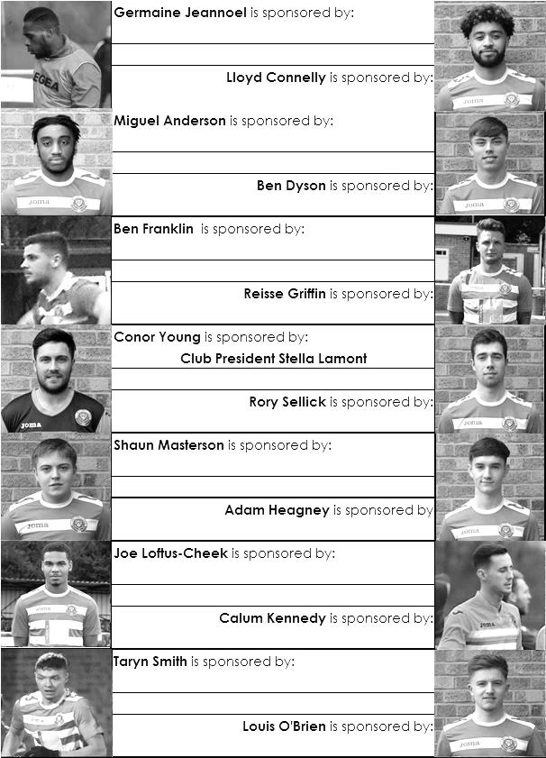

Sponsorship costs just £40 and it is easy to do. Just select a player who has not been previously sponsored and let a Committee Member know. Don’t delay, sponsor today!

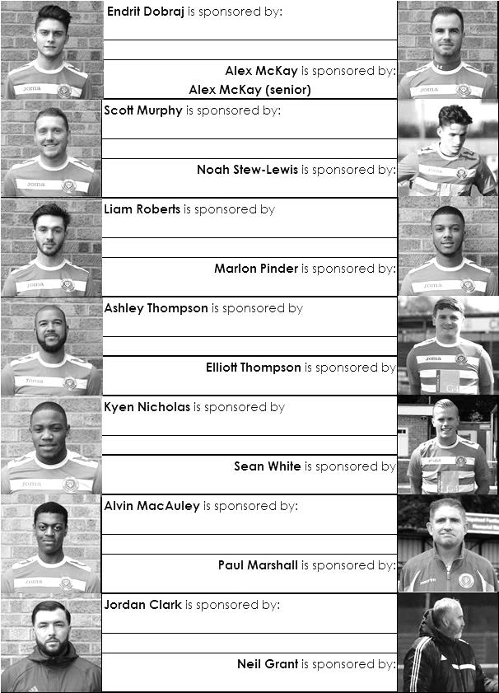

Combined Counties League Premier Division
Opponents All-time Records
inc Saturday  17th March | P | W | D | L | F | A | PPG | GD | Best  Win | Worst  Loss
Horley Town | 32 | 21 | 5 | 6 | 71 | 37 | 2.13 | +34 | 6-0 | 1-3
Banstead Athletic | 38 | 23 | 7 | 8 | 62 | 38 | 2.00 | +24 | 5-0 | 0-4
Sutton Common Rovers* | 15 | 9 | 3 | 3 | 30 | 21 | 2.00 | +9 | 4-0 | 0-5
Spelthorne Sports* | 9 | 5 | 3 | 1 | 16 | 11 | 2.00 | +5 | 6-2 | 1-5
Godalming Town | 3 | 2 | 0 | 1 | 4 | 5 | 2.00 | -1 | 2-1 | 0-3
Bedfont Sports | 12 | 7 | 2 | 3 | 21 | 19 | 1.92 | +2 | 5-1 | 0-7
Colliers Wood United | 24 | 14 | 2 | 8 | 47 | 39 | 1.83 | +8 | 4-0 | 0-5
Abbey Rangers | 6 | 3 | 2 | 1 | 12 | 5 | 1.83 | +7 | 7-1 | 2-3
Farnham Town | 17 | 9 | 4 | 4 | 30 | 25 | 1.82 | +5 | 3-0 | 1-4
Guildford City | 19 | 11 | 1 | 7 | 36 | 25 | 1.79 | +11 | 5-1 | 1-5
Westfield | 22 | 12 | 3 | 7 | 43 | 41 | 1.77 | +2 | 6-1 | 0-5
Knaphill | 10 | 5 | 2 | 3 | 20 | 16 | 1.70 | +4 | 4-0 | 2-6
Hanworth Villa | 19 | 9 | 5 | 5 | 42 | 30 | 1.68 | +12 | 5-0 | 1-4
Walton & Hersham | 53 | 25 | 11 | 17 | 105 | 101 | 1.62 | +4 | 8-0 | 1-9
Camberley Town** | 92 | 38 | 24 | 29 | 159 | 126 | 1.50 | +33 | 9-1 | 0-4
Redhill | 35 | 14 | 2 | 19 | 63 | 77 | 1.26 | -14 | 7-2 | 2-8
Chertsey Town | 51 | 19 | 5 | 27 | 77 | 95 | 1.22 | -18 | 3-0 | 0-7
North Greenford United | 13 | 4 | 2 | 7 | 19 | 24 | 1.08 | -5 | 3-0 | 1-4
AFC Hayes | 11 | 2 | 3 | 6 | 18 | 20 | 0.82 | -2 | 7-0 | 0-3
CB Hounslow United | 4 | 1 | 0 | 3 | 6 | 11 | 0.75 | -5 | 2-0 | 1-5
Balham | 2 | 0 | 0 | 2 | 0 | 6 | 0.00 | -4 | x | 0-4
* includes one loss on penalties v Spelthorne and one win on penalties v Sutton Common Rovers
** includes one abandoned match v Camberley

Match and Ball Sponsorships – 2017/18
Opponent | Date | Match Sponsor | Ball Sponsor
Banstead Athletic (FAC) | 06/08/17 | Club President - Stella Lamont
Chertsey Town | 15/08/17 | EEFC Management Committee
Redhill | 02/09/17 | Building Shop Ltd
Spelthorne Sports | 09/09/17 | In memory of Betty Dyke
Horley Town | 12/09/17 | Alex McKay (Senior)
Hanworth Villa | 23/09/17 | Jack Jarman
North Greenford United | 28/10/17 | Marvin and Kathy Hough
Farnham Town | 14/11/17 | In memory of Dave and Lizzie Marshall
Godalming Town | 21/11/17 | Building Shop Ltd
Guildford City | 02/12/17 | John Bonner
Walton & Hersham | 30/12/17 | Jeff and Arnold Pye
Merstham (SSC) | 16/01/18 | Paul Merritt
Abbey Rangers | 23/01/18 | Pete Beddoe’s grandchildren  George, Joseph, Ezara & Inaya
Sutton Common Rovers | 03/02/18 | David Ellins
Knaphill | 24/02/18 | Jack Jarman
Camberley Town | 10/03/18 | Pete Lumm
Balham | 13/03/18
Bedfont Sports | 24/03/18 | EEFC Management Committee
Colliers Wood United | 30/03/18
Banstead Athletic | 02/04/18 | Nathan Lambert – 10 years old today!
Westfield | 14/04/18
CB Hounslow United | 17/04/18
AFC Hayes | 28/04/18 | Club President - Stella Lamont
Match sponsorship costs just £60.00!

Sponsorship includes:

Admission, programmes and hospitality for three people.

A full page advert in the programme and mascot for the day (if required).

Also, you get to choose the player of the match, who will receive a prize

If you are interested, just speak to a Committee Member,
or drop me an email at: richard.c.lambert@gmail.com

First Eleven Appearances 2017/18 - (max 39)
Name | Debut | 2017/18 |  |  |  | Career Totals
 |  | App | Sub | Tot | Goals | App | Sub | Tot | Goals
AJAYI Tayo* | 06/08/2017 | 3 | 4 | 7 | 1 | 3 | 4 | 7 | 1
ANDERSON Miguel | 03/02/2018 | 4 | 2 | 6 | 0 | 4 | 2 | 6 | 0
BROOKS Jordan* | 06/08/2017 | 3 | 0 | 3 | 0 | 3 | 0 | 3 | 0
BURROWES Joshua* | 02/12/2017 | 1 | 1 | 2 | 0 | 1 | 1 | 2 | 0
CASTELL Cristian* | 06/08/2017 | 2 | 4 | 6 | 0 | 2 | 4 | 6 | 0
CAULCRICK Joshua | 17/02/2018 | 0 | 1 | 1 | 0 | 0 | 1 | 1 | 0
CLARK Jordan | 17/02/2018 | 0 | 2 | 2 | 0 | 0 | 2 | 2 | 0
CONNELLY Lloyd | 14/10/2017 | 22 | 3 | 25 | 2 | 22 | 3 | 25 | 2
DEWAR Ali* | 29/10/2011 | 1 | 2 | 3 | 0 | 56 | 42 | 98 | 10
DOBRAJ Endrit | 18/11/2017 | 12 | 3 | 15 | 0 | 12 | 3 | 15 | 0
DYSON Ben | 12/08/2017 | 22 | 10 | 32 | 2 | 22 | 10 | 32 | 2
FRANKLIN Ben | 03/03/2015 | 3 | 1 | 4 | 0 | 4 | 1 | 5 | 0
GRAHAM Bentley* | 09/02/2016 | 3 | 0 | 3 | 0 | 20 | 1 | 21 | 3
GRANDISON Kane* | 11/11/2017 | 7 | 1 | 8 | 0 | 7 | 1 | 8 | 0
GRIFFIN Reisse | 08/08/2015 | 24 | 0 | 24 | 1 | 97 | 13 | 110 | 7
HARLAND-GODDARD Tom* | 06/08/2017 | 1 | 1 | 2 | 0 | 1 | 1 | 2 | 0
HARRIS Colin* | 04/08/2012 | 9 | 0 | 9 | 0 | 34 | 0 | 34 | 0
HATFIELD Jamie* | 11/11/2006 | 9 | 1 | 10 | 0 | 258 | 14 | 272 | 6
HAYWARD Ben* | 07/03/2007 | 5 | 1 | 6 | 0 | 248 | 29 | 277 | 18
HEAGNEY Adam | 16/08/2016 | 24 | 2 | 26 | 0 | 61 | 11 | 72 | 1
HENDRY Rob* | 08/08/2015 | 16 | 1 | 17 | 5 | 84 | 23 | 107 | 28
HOUGH Kyle* | 14/08/2007 | 10 | 2 | 12 | 6 | 343 | 21 | 364 | 207
JASPER Joe* | 11/11/2017 | 0 | 1 | 1 | 0 | 0 | 1 | 1 | 0
JEANNOEL Germaine | 02/12/2017 | 2 | 5 | 7 | 1 | 2 | 5 | 7 | 1
KENNEDY Calum | 18/11/2017 | 2 | 1 | 3 | 0 | 2 | 1 | 3 | 0
LAW Franky* | 06/08/2017 | 3 | 0 | 3 | 0 | 3 | 0 | 3 | 0
LOFTUS-CHEEK Joe | 06/08/2017 | 10 | 4 | 14 | 2 | 10 | 4 | 14 | 2
MACAULEY Alvin | 10/03/2018 | 0 | 1 | 1 | 0 | 0 | 1 | 1 | 0
MARKS Samuel* | 06/01/2018 | 1 | 2 | 3 | 0 | 1 | 2 | 3 | 0
MARVELL Dale* | 15/01/2000 | 17 | 2 | 19 | 0 | 286 | 51 | 337 | 86
MASTERSON Shaun | 25/11/2017 | 4 | 3 | 7 | 0 | 4 | 3 | 7 | 0
MCKAY Alex | 20/12/2008 | 24 | 1 | 25 | 1 | 155 | 38 | 193 | 13
MULLINGS Corey* | 23/12/2017 | 0 | 2 | 2 | 0 | 0 | 2 | 2 | 0
MURPHY George | 19/03/2013 | 2 | 0 | 2 | 0 | 70 | 7 | 77 | 3
MURPHY Scott | 20/01/2007 | 26 | 0 | 26 | 1 | 38 | 2 | 40 | 1
MYERS Antony* | 23/12/2006 | 1 | 0 | 1 | 0 | 76 | 33 | 109 | 9
NICHOLAS Kyen | 13/01/2018 | 8 | 2 | 10 | 3 | 8 | 2 | 10 | 3
NWACHUKWU Jason* | 01/10/2016 | 9 | 4 | 13 | 2 | 26 | 20 | 46 | 3
O'BRIEN Louis | 28/08/2017 | 1 | 4 | 5 | 0 | 1 | 4 | 5 | 0
PINDER Marlon | 13/01/2018 | 7 | 0 | 7 | 1 | 7 | 0 | 7 | 1
ROBERTS Liam | 12/08/2017 | 19 | 9 | 28 | 4 | 19 | 9 | 28 | 4
ROBINSON Sam* | 22/10/2011 | 5 | 0 | 5 | 0 | 66 | 6 | 72 | 14
ROSE Daniel* | 25/10/2016 | 14 | 2 | 16 | 1 | 16 | 7 | 23 | 1
SAMPAT Mohammed* | 23/12/2017 | 3 | 0 | 3 | 0 | 3 | 0 | 3 | 0
SELLICK Rory | 27/01/2018 | 6 | 0 | 6 | 1 | 6 | 0 | 6 | 1
SMITH Andy* | 25/08/2017 | 2 | 0 | 2 | 0 | 2 | 0 | 2 | 0
SMITH Taryn | 28/10/2017 | 7 | 3 | 10 | 0 | 7 | 3 | 10 | 0
STEW-LEWIS Noah | 09/12/2017 | 6 | 2 | 8 | 0 | 6 | 2 | 8 | 0
THOMPSON Ashley | 21/08/2017 | 28 | 1 | 29 | 3 | 28 | 1 | 29 | 3
THOMSON David* | 02/09/2017 | 2 | 2 | 4 | 0 | 2 | 2 | 4 | 0
TURPIE Ali | 31/03/2016 | 1 | 0 | 1 | 0 | 12 | 1 | 13 | 0
WHITE Sean | 02/08/2014 | 14 | 7 | 21 | 2 | 20 | 20 | 40 | 5
YOUNG Conor | 07/03/2015 | 24 | 0 | 24 | 0 | 25 | 0 | 25 | 0
* Player has left the club

Salts Super Six Predictor
The Salts Super Six Predictor jackpot was recently claimed and is now at £157 for today’s match. The tickets are on sale to the left of the gate and the matches on the ticket are to be played today!

The competition is easy to play! To win, you simply need to predict the results of six matches correctly from the three options, fill in the form and make sure it is back with our seller before the deadline on the ticket. The latest fixtures are shown below.

If you are a club regular, you just need to place your name on the sheet, although if you aren’t, then we’ll need a contact number from you too. We will announce any winners on the website within three working days, so don’t worry, we won’t miss you!

Please note that if there is more than one winner, the prize pot would be shared between the winners. All you need to do now is have a go, as many times as you like!

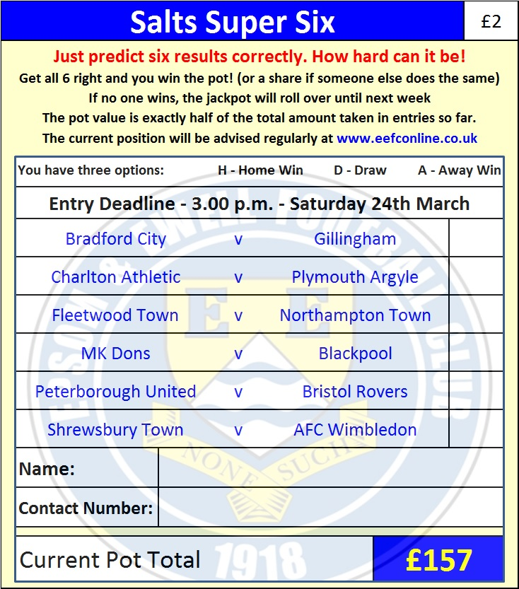
Good luck!

Combined Counties League – Premier Division
Saturday, 24th March 2018 - Kick-off 3.00 p.m.
Epsom and Ewell  (Royal Blue & White hoops) | V |  | Bedfont Sports  (Red and Black / Black)
Squad | NUMBERS |  | Squad
Conor Young |  |  | Rourke Pickford
Endrit Dobraj |  |  | Matt Baxter
Reisse Griffin |  |  | Julius Mngadi
Adam Heagney |  |  | Matt Baxter
© Alex McKay |  |  | Simo Mbonkwi
Ashley Thompson |  |  | Addison Garnett
Marlon Pinder |  |  | Jack Mills
Scott Murphy |  |  | Scott Harris
Kyen Nicholas |  |  | Tim Pitt
Rory Sellick |  |  | Jimmy Hibbert
Lloyd Connelly |  |  | Jamie Reaad
Noah Stew-Lewis |  |  | Jake Hicks
Ben Dyson |  |  | Matt Riggs
Liam Roberts |  |  | Joe Jackson
Miguel Anderson |  |  | Alex Rose
Rob Hendry |  |  | Paul Johnson
Ben Franklin |  |  | Jamie Richards
Shaun Masterson |  |  | Jacob Lambe
Joshua Caulcrick |  |  | Darryl Sanders
Jordan Clark |  |  | Jason Nwachukwu
Alvin MacAuley |  |  | Chris Spencer
Ryan Gunter
Germaine Jeannoel
Neil Grant | MANAGER |  | Paul Johnson
Alex McKay | ASSISTANT |  | Jimmy Hibbert
Jordan Clark / Jimmy Hendry | COACH / PHYSIO |  | Gary Ross / Dee West
REFEREE: M.Coen
ASSISTANTS: R.Wells, R.van Niekerk
Today’s Match and Match Ball are kindly sponsored by:
the EEFC Management Committee

OUR NEXT VISITORS TO HIGH ROAD
Colliers Wood United
Cherry Red Combined Counties League – Premier Division
Friday 30th March 2018 – 11.30 a.m.

